UNVEILING MARKET INSIGHTS

1 INTRODUCTION

1.1 Overview

An introduction that provides a brief overview of your business and the reason you conducted the market research.

Include a summary of the market research process and the results you have analyzed.

1.2 purpose

Start by telling a story that illustrates your points. This could be case study of a successful marketing campaign.

Think of interview, focus groups of customers feedback. Make sure you ask customer feedback questions to draw the juiciest insight.

2 PROBLEM DEFINITION & DESIGN THINKING

2.1 Empathy map

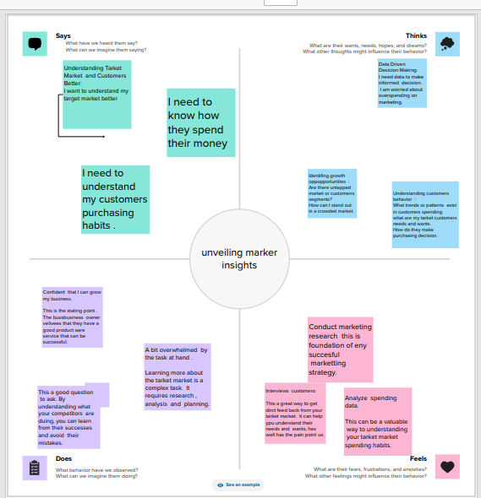

2.2 Ideation & Brainstorming map

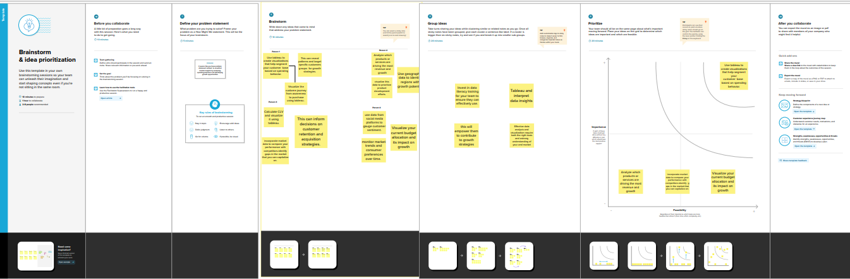

3 RESULT

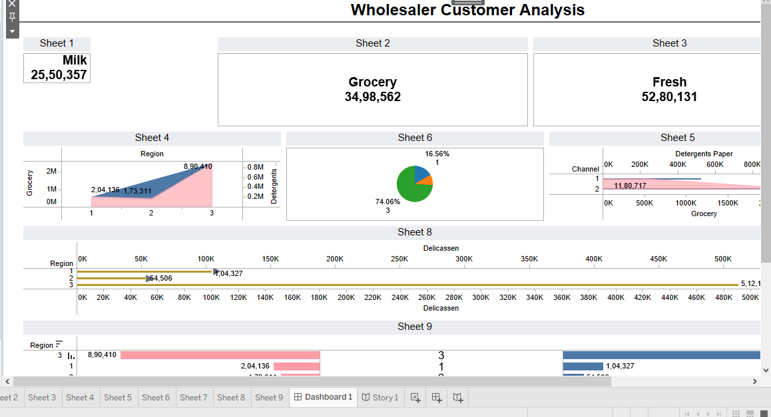

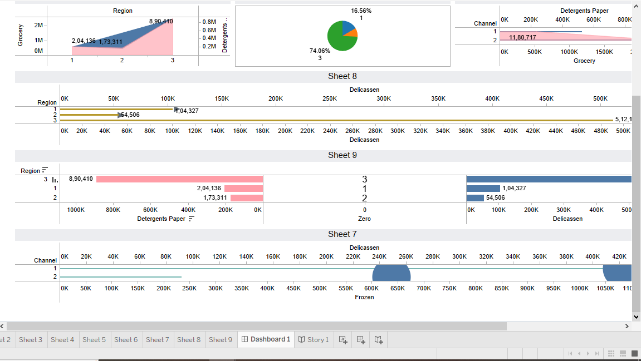

Story

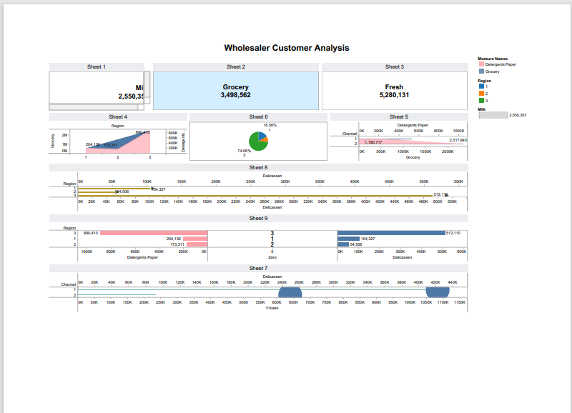

4 ADVANTAGES & DISADVANTAGES

1 Informed decision making

One of the primary market research advantages is informed decision making, conducting through research , business gain valuable insights into customer preference.

This knowledge empowers them to make informed decision regarding product development. Pricing strategies and marketing campaigns. the market research can identify market gaps.

2 Targeted marketing

Market research enable targeted marketing efforts. By understanding the target market businesses can tailor their marketing messages and strategies to resonate with specific customer segments.

Market research helps businesses identify the most appropriate marketing channels. messaging,and positioning to reach their target audience effectively.

3 Gaining a competitive advantage

Market research provides businesses with a competitive advantage. By monitoring industry trends. customers preference and competitor strategies, companies can identify selling propositions.

Market research enable businesses to stay updated on industry developments, anticipate market shifts, and proactively adapt their strategies to stay ahead.

DISADVANTAGES

1 cost and time

The first disadvantages is their cost and time involved, conducting market research can expensive and time consuming. Especially for small businesses with limited budgets and resources.

Small businesses may need to carefully allocate their resources to ensure an effective nd efficient research process.

2 Data accuracy

The second disadvantages is the potential for data accuracy and reliability issues. The quality of market research data heavily relies on the data collection methods and samples size. if not conducted carefully, there is a risk of obtaining baised or inaccurate data.

Businesses need to ensure the research methodologies, proper sampling technique, and rigorous data analysis to minimize in accuracise.

3 Information overload

The third disadvantages is the potential for information overload. With the abudance of data available through market research. Businesses may face the challenge of processing and analysing large volumes of information.

5 APPLICATIONS

Market insights is to learn about and analyse the market. Data on the market consumers, and competitors must be gathered, analysed and interprented by individuals in this role.

The insights allow you to preceview needs that arent even known yet by the buyer themselves.

People develop improved understanding of their own characteristics and how they may be preceived, and those of others with whom they work.

Insights discovery helps to diffuse potential conflict and misunderstanding in the workplace and is also used specifically for team buildings.

6 CONCLUSION

Market insights are a become guiding organization through the compecities of the business landscape. By leverages these insights, businesses can make strategic decisions that not only lead to profitability but also foster innovation.

Customer satisfaction and sustainable growth. In an era where information is power, organizations that embrace the treasure trove of market insights are better required to navigated changes, seize opportunities, and emage as leaders in their industries.

7 FUTHURE SCOPE

1 The traditional market research agencies that refuse to change will go out of business.

2 DIY market research will catch on even more and will denocratic our sector.

3 Social listening analysis will be a must have for every marketing and market research manager.

4 Agile research will become mainstream and will be facilitated by online communities.

5 Micro surveys and intercepts will eventually replace long monthly customer tracking studies.

8 APPENDIX

<https://WWW>.reseachandmarkets.com